**University of Petroleum and Energy Studies**

School of Computer Science

Department of Cybernetics



**Graphics & Animation Tools**

**LAB FILE**

**(Session: 2020-2021)**

Course: B. Tech with Specialization in Open Source and Open Standards





**Experiment 1 : Installation of Gimp and Blender.**

**Installation of Gimp:**

**(for Mac)**

**Step 1 :** Download the Gimp installer from [gimp/org/downloads](https://www.gimp.org/downloads/)/

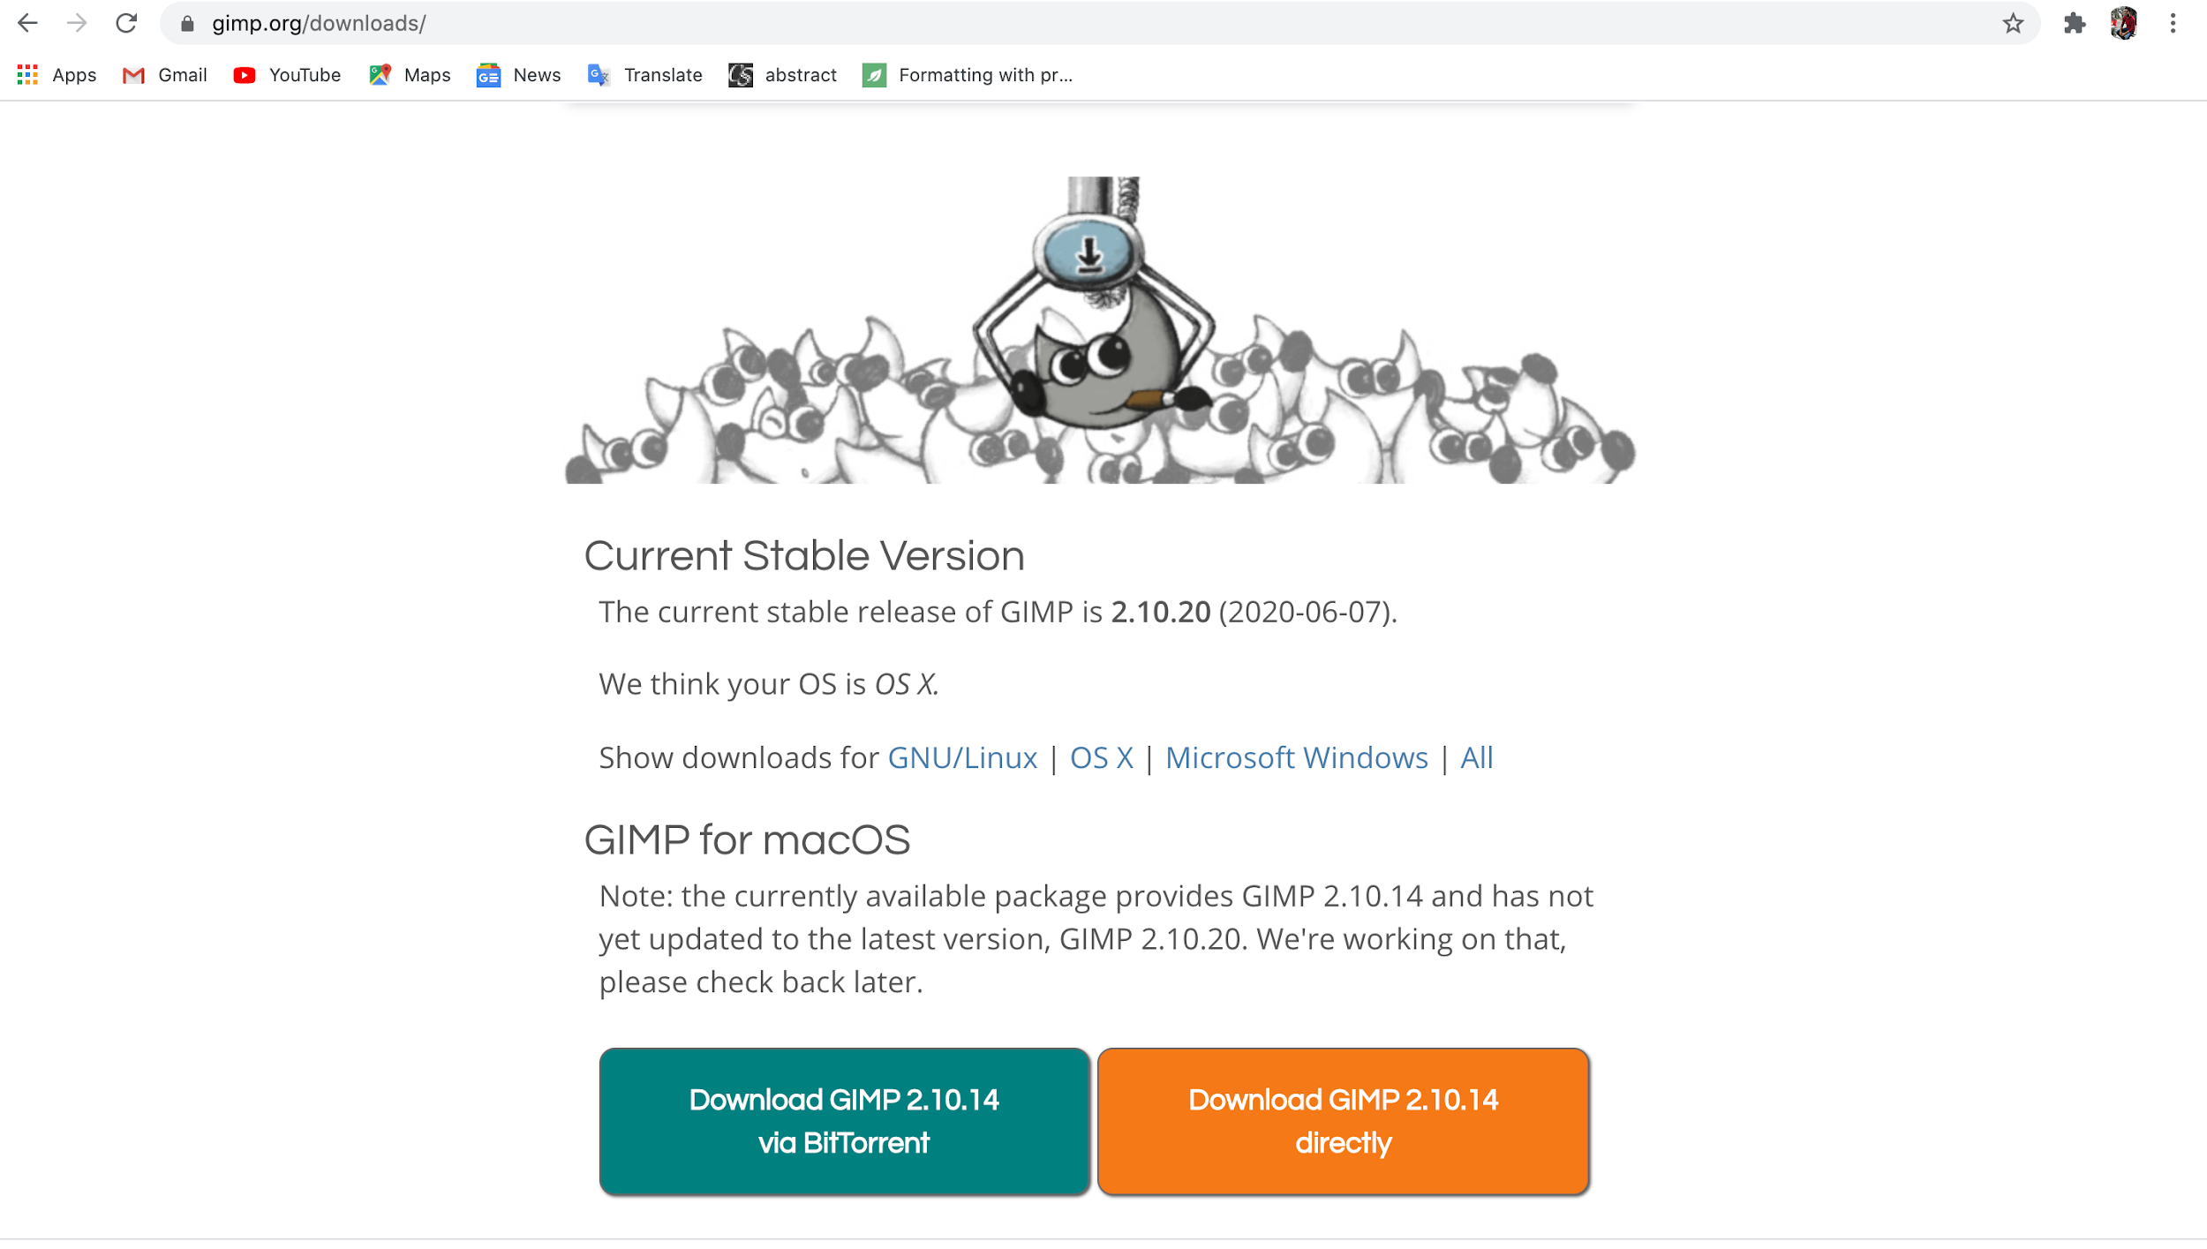

**Step 2 :** Run the Installer and Move it to the Applications folder.

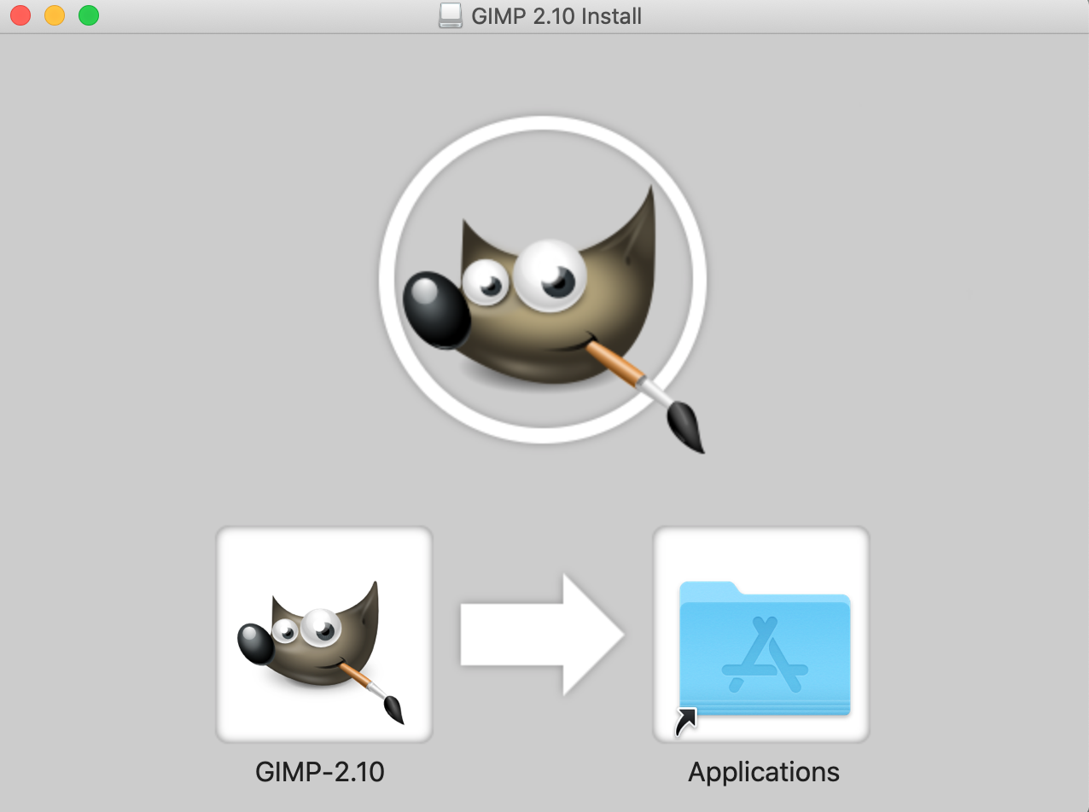

**Step 3 :** Open it from the Applications folder. You can start using Gimp.

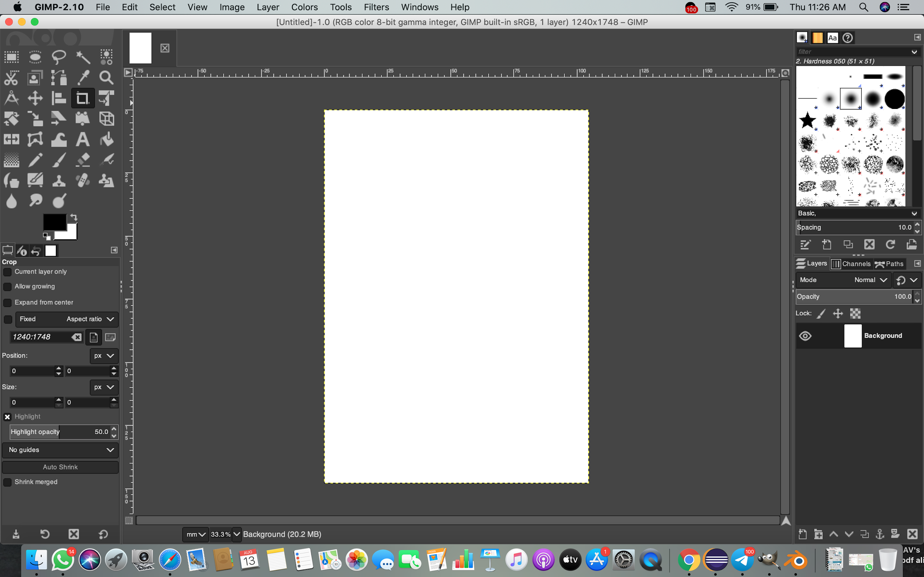

**Installation of Blender :**

**(For Mac)**

**Step 1 :** Download the blender installer from [blender.org/](https://www.blender.org/). Click on the download icon.

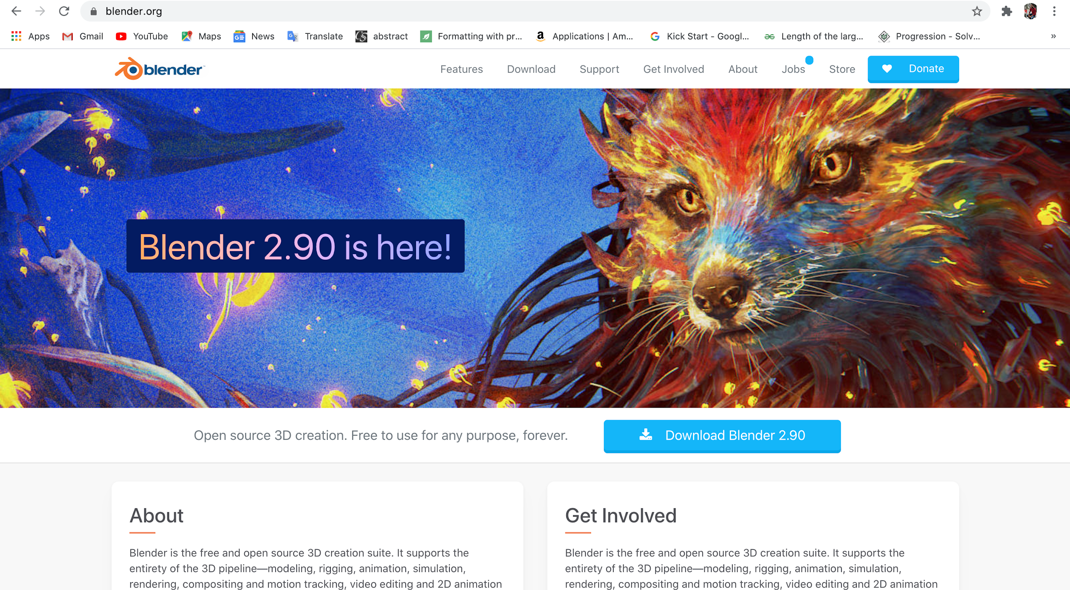

**Step 2 :** Once downloaded run the installer and you can start using blender app from the Applications folder.



